Dhruvil Dobariya

dhruvildobariya21@gmail.com

Abstract

[Draw your reader in with an engaging abstract. It is typically a short summary of the document.   
When you’re ready to add your content, just click here and start typing.]

Debug Learn

Documentation



Index

1 Debug 1

1.1 Introduction 1

1.2 Debug Points 1

1.3 Different Window 1

1.4 Conditional Debug Point 3

1.5 Data inspector 4

1.6 Editing 4

1.7 Conditional compilation 4

1. Debug

# Introduction

* Debugging is the process to finding and resolving bug in any project.
* Visual Studio provides many functionality to debug our project.

# Debug Points

# Different Window

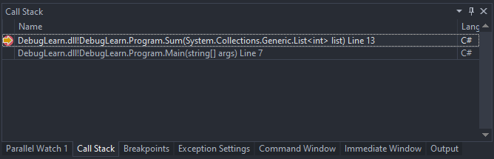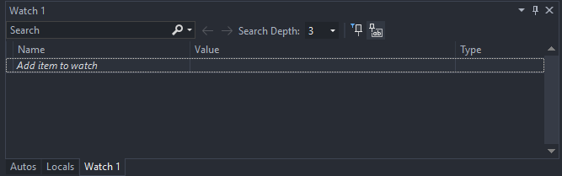

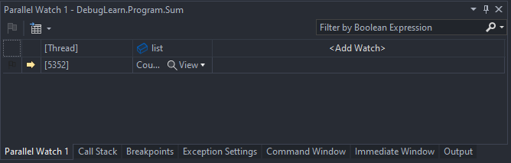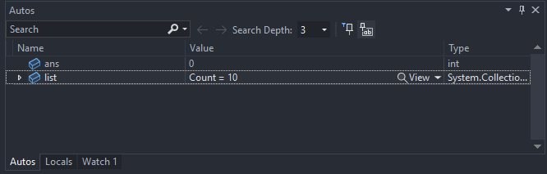

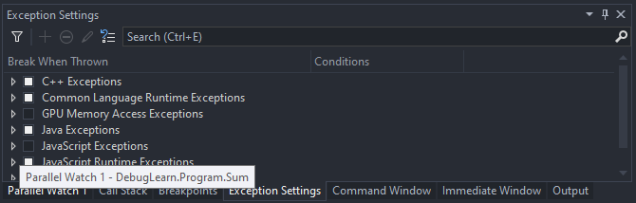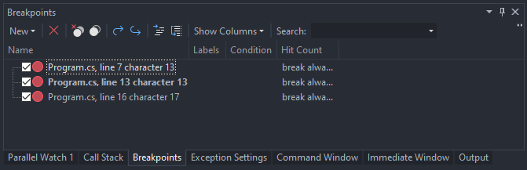

# Conditional Debug Point

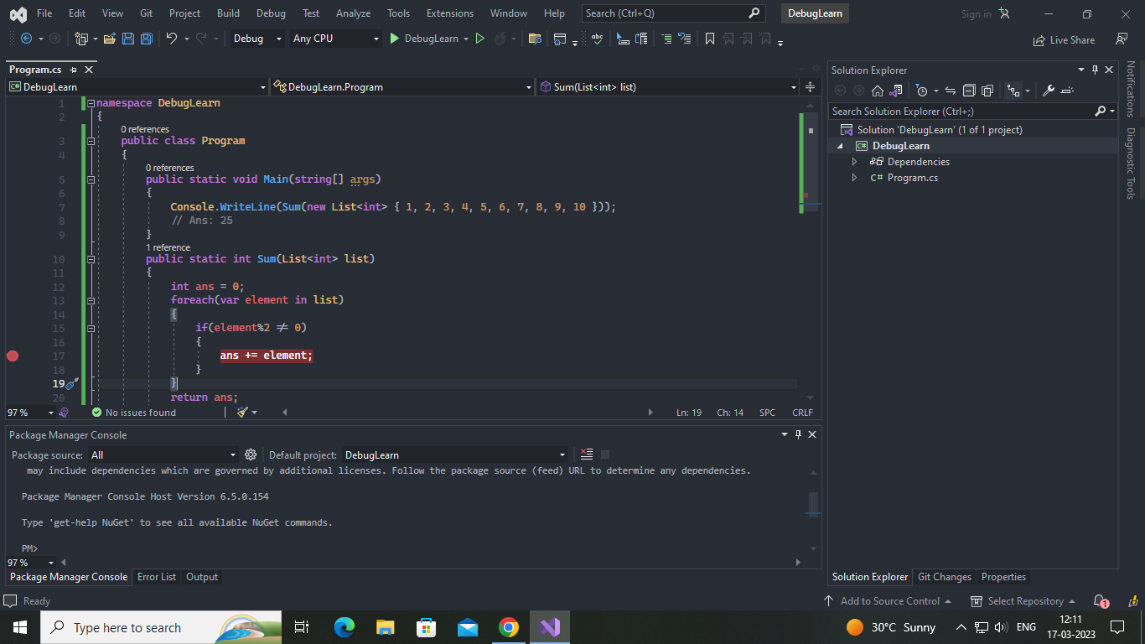

# Data inspector

# Editing

# Conditional compilation

